20-B-CP5046-BNE-INT-SP22

ICT Project 1: Analysis and Design

Assignment #1



**Team Members:**

|  |  |  |
| --- | --- | --- |
| **1** | **Thi Thanh Mai Pham** | **13729734** |
| **2** | **Ayesha Mamtora** | **13732722** |
| **3** | **Gia Hoi Tran** | **13591878** |

Table of Contents

1 Team formation 1

2 Project description 2

2.1 Existing website 2

2.2 Requirement description 2

2.3 Target audience 3

2.4 Main goals 3

2.5 Market research 3

2.6 Major milestone 4

3 Project scope of the full final-release 5

4 Project client signature 6

5 Project development and release ICT infrastructure 10

5.1 Database design 10

5.2 Configuration management/version control 11

5.3 Hosting details 12

5.4 Programming languages 12

5.5 Integrated development environment 13

5.6 Prototype 15

5.7 Testing 19

6 References 20

# Team formation

Our group has three members: Thi Thanh Mai Pham, Gia Hoi Tran, Ayesha Mamtora. In order to collaborate effectively, we try to communicate by group chat on Facebook and on every Wednesday, we have a quick meeting to discuss our project. We also spent time having a meeting with our client to discuss requirements, feasible solutions and timeline for our project. To complete the assessment, each member is assigned with different tasks

|  |  |
| --- | --- |
| Team Member | Task |
| Thi Thanh Mai Pham | * Project Overview * Task Assignment * Team Management and Organisation * Project description * Market research * Site map * Prototype * Project Review and Evaluation * Team member support |
| Ayesha Mamtora | * Client Communication * Team member support * Project details * User stories * Project timeline * Agreement form |
| Gia Hoi Tran | * Database design * Project development and release ICT infrastructure   + Configuration management/version control   + Hosting details   + Programming languages   + Integrated development environment   + Testing * Team member support |

# Project description

With the development of information technology recently, it is necessary for every business to create a website. This is the best method to introduce their products to all customers because a majority of customers will visit the website before making a purchase. Having a website is an opportunity to make a great first impression and gain reliance. Since the website is on 24/7, it is easy to post updates and announcements to customers. In general, creating a website is one digital marketing way that many companies use nowadays.

With the globalisation and integration, logistics plays an essential part in supply chain management. It is used to coordinate the movement of products timely, safely and effectively. Customers can send packages to local friends and foreign friends across the globe as well. Hence, more and more logistics companies are established. Among a large number of logistics companies, customers often make use of the internet to find more information for a reliance business. This is the reason why we have chosen a project of web development for a logistic company.

The website is developed for a company named “Triton Global Shipping” which has main offices in Australia and offices in India and Sri Lanka. Accessing the website, customers can know more about this company, place from and to where the package is shipped, make an order for their shipping, etc. Further, customers can also be able to create an account and login as regular customers.

## Existing website

Business already has a website -<http://www.tritonglobalshipping.com/>. However, it doesn’t provide good user interface and user experience. Here are some drawbacks:

· User interface is simple.

· It is not smooth transition between pages

· Too much blank space in footer

## Requirement description

Triton Global Shipping has their own website, however it is quite simple with minimal functionality. Our client wants to improve this website with better user interface and user experience. The new website should look more attractive, have ‘Register/Log in’, ‘Request an order’, ‘Our network’ page. When a customer makes an order, the details of this order (information about customer and the package) will be sent directly to the phone number of the manager.

## Target audience

We are considering businesses, people from 20-50 are the main target audience. Moreover, business owners also are users because they will interact with their customers through website and store data of customers and shipping in a database for business analysis.

## Main goals

* Providing a website with a good user interface, easy to use, consistency between pages.
* Providing main functions: users can create an account, log in, check where the package can be shipped from and to, request an order, details of the order can be sent to the manager's phone number.
* Information about the customer and shipping package can be stored in the database.
* All information is secure.

## Market research

There are many logistics companies over the world now. Some existing companies which have been studied as follow with the best features they provide to visitor:

· <http://www.kodiship.com/>

Having ‘Our network’ page to show the places where the company ships packages from and to. However, there are too many information and links in home page

· <https://www.onlinelogisticssolutions.com/>

It has a good user interface. The form to make an order is clear and detailed

· <https://brisbanelogistics.com.au/>

This website is informative, but there are too many words make it is boring

· <https://www.dhl.com/global-en/home.html>

This website is attractive and provides enough information for customers. Having a tracking number helps customers keep track of their package. ‘Customer Service’ page is very convenient for customers if they have any questions, it also has dropdowns for many countries.

· <https://www.tollgroup.com/>

This website provides a lot of photos about the company and staff working for this company. It makes customer feel more reliable and make website more appealing

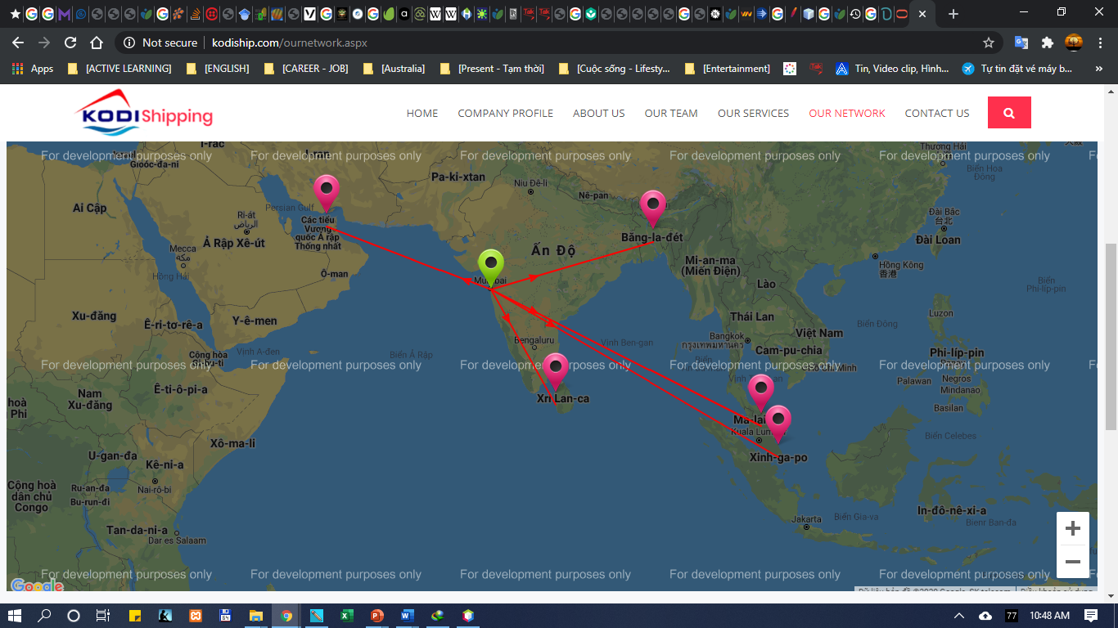

## Major milestone

Because we work in groups, so planning is very important to have a project done effectively. Therefore, we divided our project into 3 milestones:

· Milestone 1: Home page, ‘Contact Us’ page, ‘Register/Log in’ page, ‘About Us’ page, ‘Request an Order’ page, ‘Our Network’ page, Order’s Message on Mobile phone,

· Milestone 2: Special features: Tracking number, User Generated Reviews and FAQ page, Live Chat, Advance Payment Option, Special Offers, Testing and Enhancement

· Milestone 3: Testing and fixing

# Project scope of the full final-release

We are group of three. Our project will be divided into three iteration Alfa release, Beta release and final release. If we work for 2 days a week, starting after mid-term break this trimester, we got 5 weeks’ time for alpha release. So, milestone will be 3*2*5 =30 days. Implementation, testing and final release of our project will be done in ICT2. So, milestone will be 60 days for second and third iteration.

USER STORIES FOR ALPHA RELEASE

|  |  |  |  |  |
| --- | --- | --- | --- | --- |
| Sr. No. | Title | Description | Client Priority | Time estimate(days) |
| 1. | Home Page | We have to design home page such that it consists of description about the company and the services provided by it. | `10 | 2 |
| 2. | Contact Us | Will consist of the information about the company, so that the customers can contact company with any enquiry | 10 | 3 |
| 3. | About Us | Company’s description | 10 | 2 |
| 4. | Our Networks | User can view on the map, network of the company. Which locations are catered from their desired location? | 10 | 4 |
| 5. | Request an Order | User can ask for the quotation for shipping their product(s) | 10 | 5 |
| 6. | Register/Login | There will be to logins. Admin login will keep track of all orders, whereas user login will facilitate users to place order with the company | 10 | 7 |
| 7. | Order’s Message on Mobile Phone | Whenever user places an order with the company, client should receive message of that order | 10 | 7 |

USER STORIES FOR BETA AND FINAL PHASE

|  |  |  |  |  |
| --- | --- | --- | --- | --- |
| Sr. No. | Title | Description | Client Priority | Time estimate(days) |
| 1. | Tracking | Docket number to be provided to the customers so that they know exactly where parcel is | 20 | 10 |
| 2. | User Generated Reviews and FAQ page | Users can provide rating as per their satisfaction and also comment about the services. For ease of customers, there will be list of FAQs | 20 | 10 |
| 3. | Live Chat | It will facilitate user to ask questions on chat to the company’s assistants | 30 | 10 |
| 4. | Advance Payment Option | Users can make early payment of their parcel(s) online from their debit/credit card or PayPal | 30 | 10 |
| 5. | Special Offers | To attract customers, special offers will be given to them based on the services they take from the company | 30 | 10 |
| 7. | Testing and Enhancement | Functionality of the web applications will be tested and they will get back in case any enhancement required | 40 | 10 |

If customers want to make further changes to website, we have planned some future implementations: -

1. Expanding services required by user.
2. Enhance the security of the website.

# Project client signature

Business Name: TRITON GLOBAL SHIPPING (PVT) LTD

Client Name: Luke Spiller

Mail id: luke@tritonglobalshipping.com.au

Agreement Letter: 





# Project development and release ICT infrastructure

## Database design

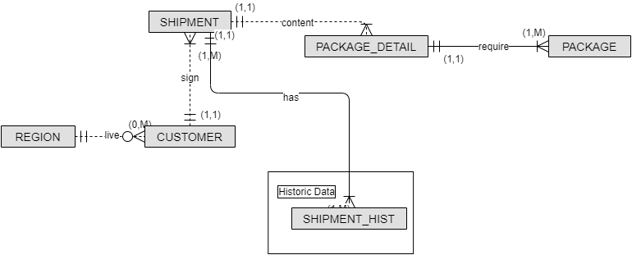

Entity- Relationship Diagram for our site is as follow:

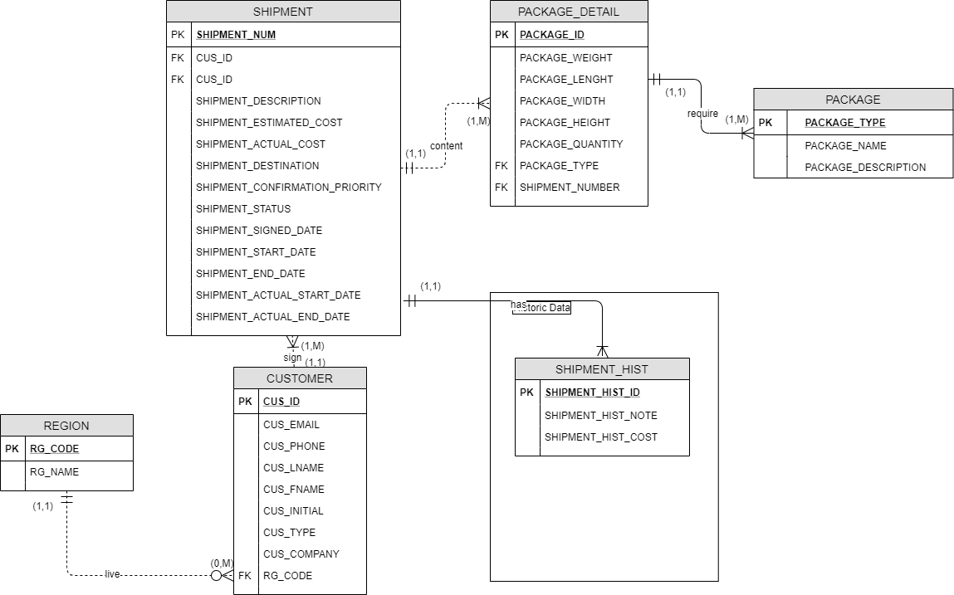

* Customer: have information (Name, Email, Phone, …)
* Shipment order: one customer has zero to many shipment order
* In one shipment order, there can be one or many packages
* Shipment order confirmation priority: in 1 hour, 2 hours, 3 hours, 6 hours, 12 hours, 24 hours after customer make an order
* Shipment status: Pending, Late, Cancelled, Confirmed, Shipping, and Done
* A package can be dangerous or non-dangerous type
* One package has its type and attribute (weight, length, width, height, and quantity)
* Table ‘Shipment History’ is to save old shipment

## Configuration management/version control

A configuration is the collection of functional and physical characteristics of a final deliverable specified in the specification and accomplished in plan implementation. This management is useful for monitoring the deliverables and preventing errors. This plays an significant part in the contribution of a quality product

A feature of software configuration management is the management of changes to documents, computer programs, large web sites, and other collections of information. It is called version control, also known as revision control or source control.

Version control systems are a software resource category that helps a software team handle changes in the source code over time. Version control software keeps track of every change to the code in a particular database type.

GitHub is used to manage the source code with the version control system, Git. Git is an open source device that provides various highlights such as changes to update, submit, consolidate, and push / pull. It will help IT team grow their product in time.

First, a repository called "Triton Global Shipping" was created. Project members are added to allow project they to access the GitHub in order to modify documents and resources via IDE (Integrated Development Environment)

GitHub link to the repository:

|  |
| --- |
| <https://github.com/tgh1107/Triton-Global-Shipping> |

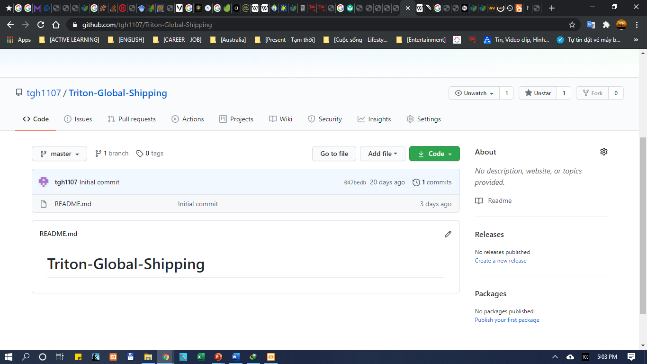

Every team member should have a GitHub account and have to be added accordingly. Using the username of each individual we can send an invite for them to join the team.

## Hosting details

To implement the project, there are some platform

1. Website server: domain: http://www.tritonglobalshipping.com.au/
2. FTP server
3. Remote phpMyAdmin
4. Database server

## Programming languages

For developing our web-based application, the numerous programming languages are used to complement the requirements and the features of the project. Mainly we will use

* HTML (Hyper Text Markup Language),
* CSS (Cascading Style Sheet),
* JavaScript,
* PHP (Hypertext PreProcessor).
* MySQL

**HTML** is the standard markup language used to build web pages. The building blocks of HTML pages are HTML elements, and its items are labelled with tags. The latest version of HTML is HTML 5, with new elements, attributes, and behaviors, and a larger set of technologies that allows the building of more diverse and powerful web sites and applications.

**CSS** (Cascading Style Sheets) is a style sheet language used to describe a text written in a markup language such as HTML. CSS, alongside HTML and JavaScript, is a core technology of the World Wide Web. CSS 3 is the newest version, enabling immersive web apps that function both on a desktop browser and on a mobile device.

**JavaScript** is a high-level, interpreted programming language that conforms to the ECMAScript specification and is often abbreviated as JS. JavaScript has curly-bracket syntax, dynamic scripting, object-based layout orientation and first-class features. The latest JavaScript version is 1.8.5.

**JQuery** is a JavaScript library designed to make traversal and manipulation of the HTML DOM tree as well as event handling, CSS animation and Ajax easy. It is open-source free software with the permissive MIT License. Web analytics reveal that it is by a considerable margin the most widely distributed JavaScript library.

**PHP**: Hypertext Preprocessor is a programming language which was originally developed for web creation. PHP code can be implemented with a command line interface (CLI), embedded in HTML code or coupled with various web design systems, online content management systems, and software frameworks. Currently, the latest stable version is PHP 7.4.9.

**MySQL** is a SQL-Structured Query Language-based relational database management framework. The latest MySQL version is 5.5.25a

The programming languages are used for a wide variety of purposes including applications for data warehousing, e-commerce, and logging. In conjunction with a scripting language such as PHP. Websites can be developed and communicate with a MySQL database in real time to quickly show categorised and searchable information to a website user.

## Integrated development environment

An Integrated Development Environment (IDE) is a software suite that consolidates the basic resources required for software writing and testing. Developers use various tools in the development, create, and testing of software code. Tools for development also include text editors, application libraries, compilers, and platforms for testing.

Without an IDE, a developer has to separately select, install, integrate and manage all of these tools separately. An IDE combines together all of those development-related tools as one platform, programme, or service. The integrated toolset is designed to simplify the development of software, detect and eliminate coding errors and typos.

* Local Server: XAMPP
* Database Design: draw.io
* Programming IDE: NetBeans
* Team Communication: Messenger

**XAMPP**

XAMPP is a free and open source web server cross-platform stack software kit built by Apache Friends, consisting primarily of Apache HTTP Server, MariaDB database, and PHP and Perl programming language script interpreters. Since most actual deployments of web servers use the same components as XAMPP, the transition from a local test server to a live server is possible. The latest version of XAMPP for Windows is 7.4.9 with PHP 7.4.9 version and MySQL 5.5.25a

**Database Design: draw.io**

draw.io is the de facto technology for building diagramming software. It is an open source stack and end user application used more widely. It is designed for developers, IT, network admins, designers, and process analysts, it is a web-based tool that helps create, publish, and share diagrams in various formats.

**NetBeans**

This tool comes with rich features that support multiple programming languages. NetBeans was originally used for Java development but the latest version of this tool for PHP development services is lightweight, fast, and supportive. This provides extensions for other languages such as Java, C++ and HTML5. It facilitates the development of mobile apps and languages to a wide scale. Almost all common PHP frameworks can work with this open-source PHP development tool. NetBeans PHP IDE provides different features unique to web application creation with the latest versions of PHP. Latest LTS version of NetBeans is12 LTS (NB 12.0), released on June 4, 2020.

NetBeans also supports GitHub to store programming code online. It is a desktop application built with HTML, JavaScript, CSS, and PHP integration.

**Team Communication: Messenger**

Communication resources provide any resource (offline or online) that can help the team understand and understand others. Group or inter-office collaboration methods include common tools such as email and phones as well as online conferencing apps and software, screen sharing, file sharing, group messaging and collaborative work management. Popular communication business tools include paper tools for collaboration, file sharing tools, chat and messaging tools, knowledge base tools, voice and video conference tools, and project management software

## Prototype

A prototype is an initial version of a system used to demonstrate concepts and try out design options. In other words, the goal of a prototype is to evaluate an idea. Further in this document we have put some design samples of implementation of the system. It provides limited and main functional capabilities of the proposed system

SITEMAP

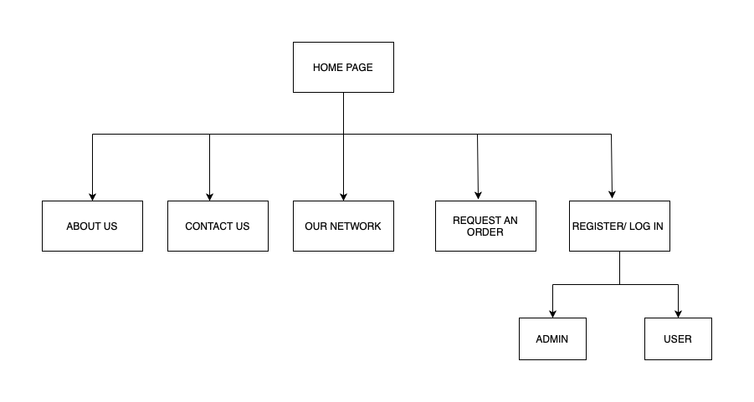

HOME PAGE

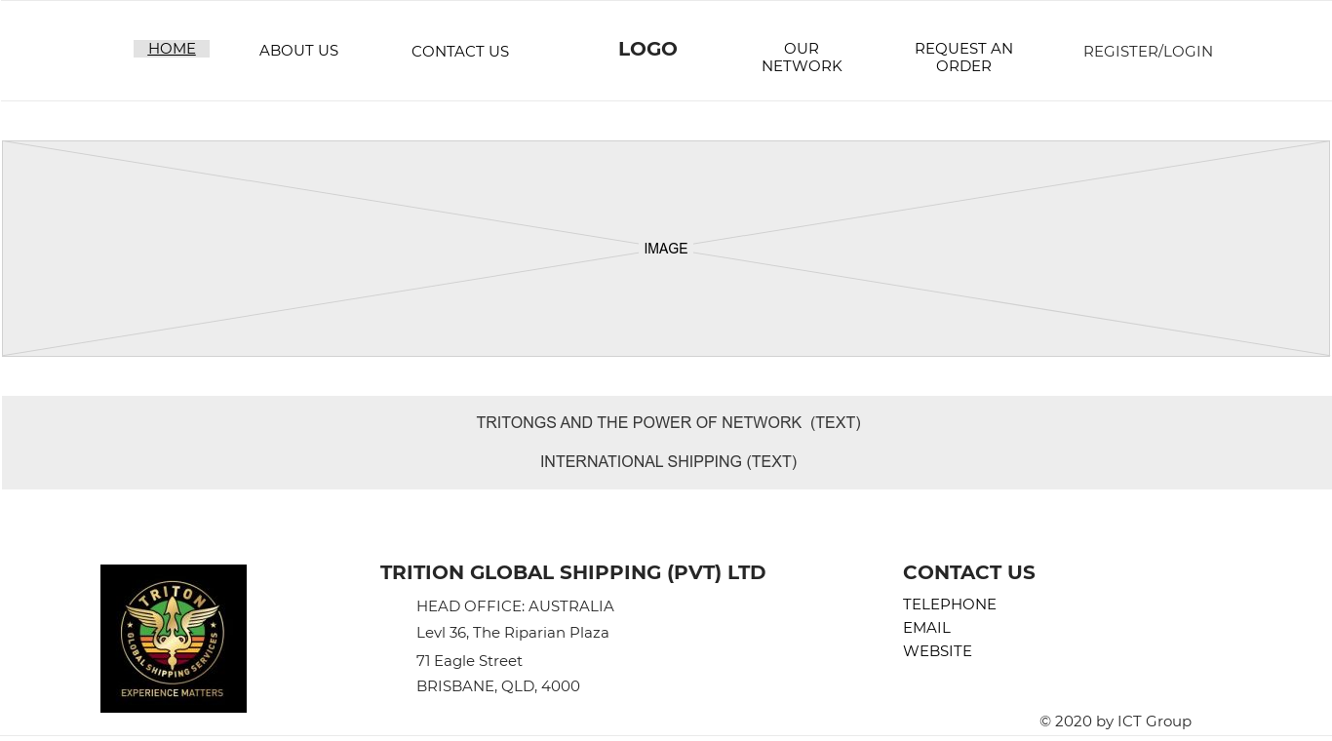

“ABOUT US” PAGE

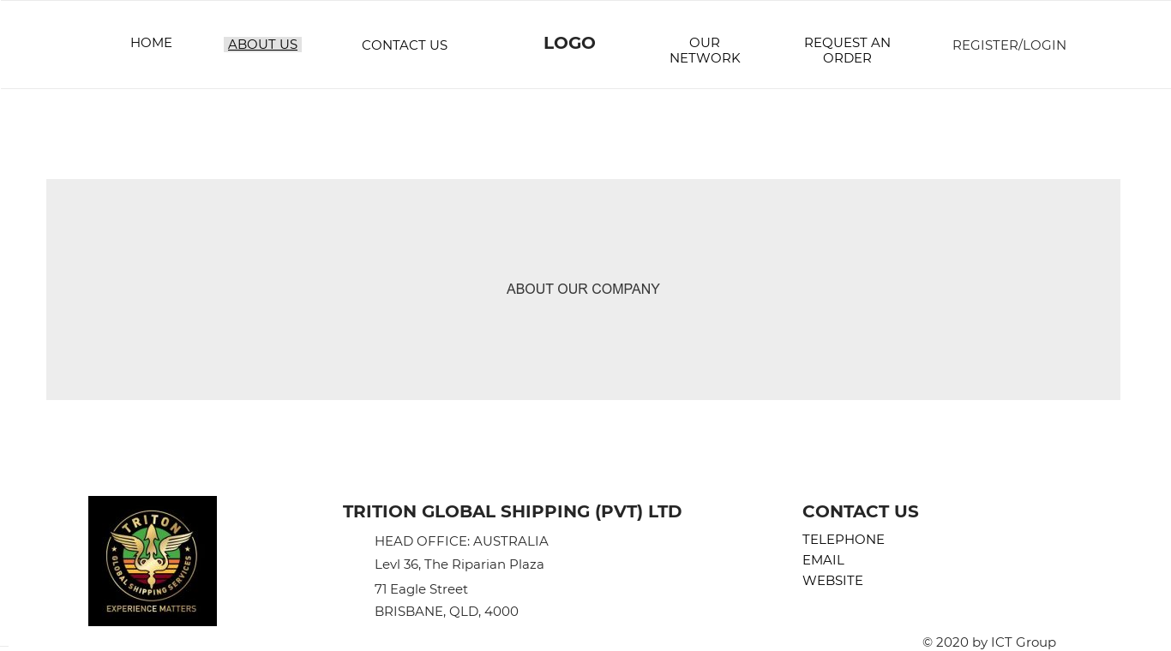

“CONTACT US” PAGE

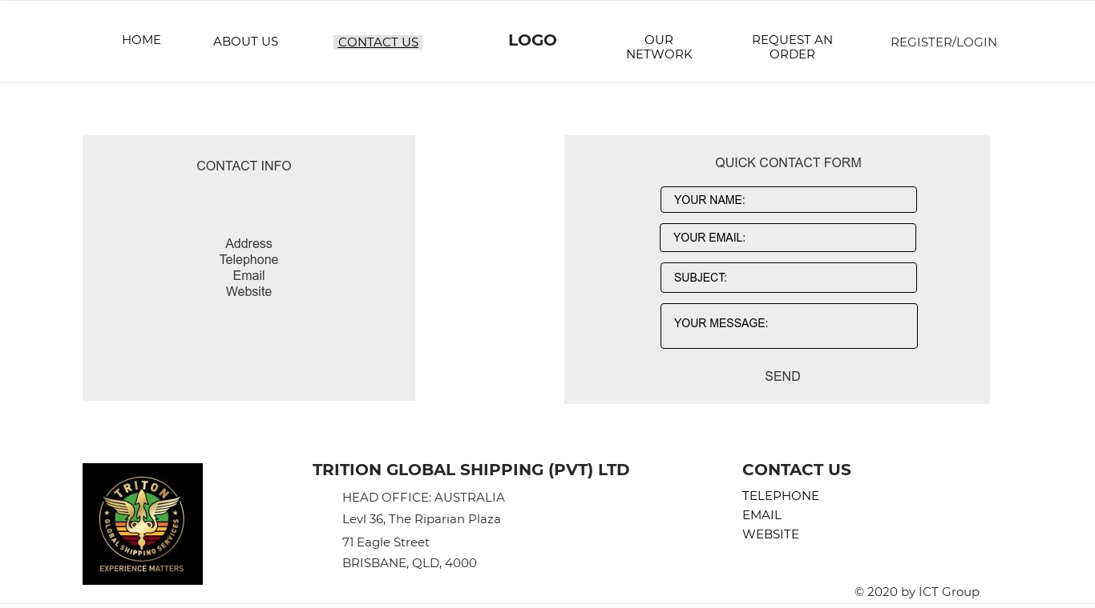

“OUR NETWORK” PAGE

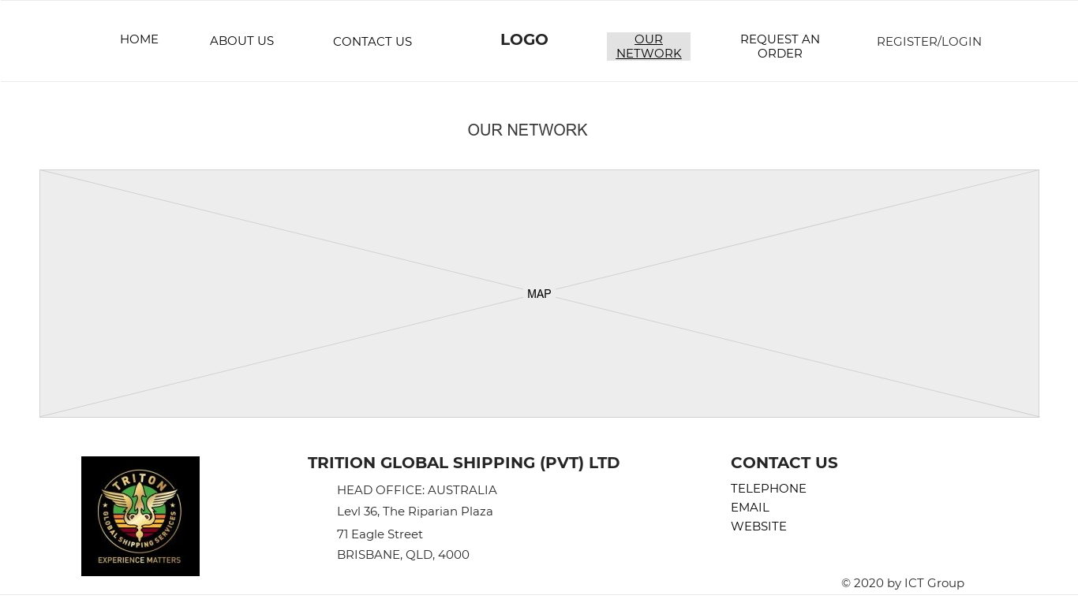

“REQUEST AN ORDER” PAGE

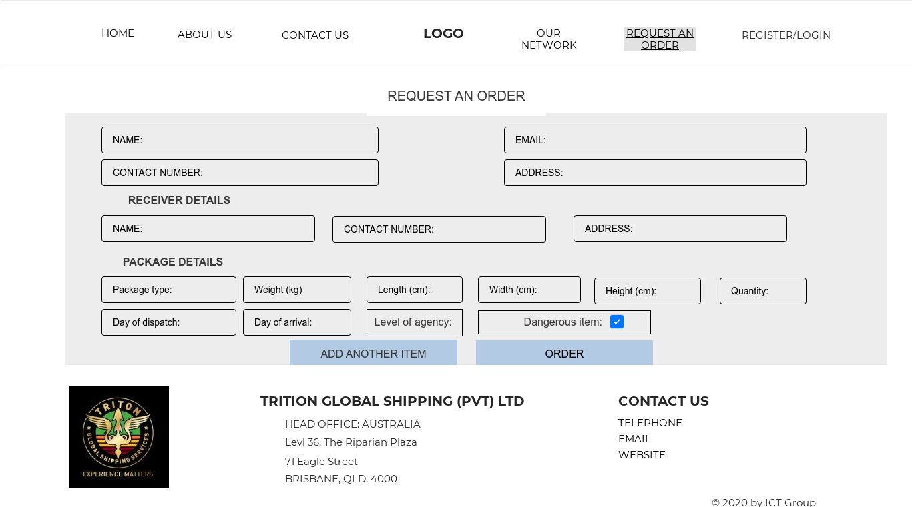

“REGISTER/LOGIN” PAGE

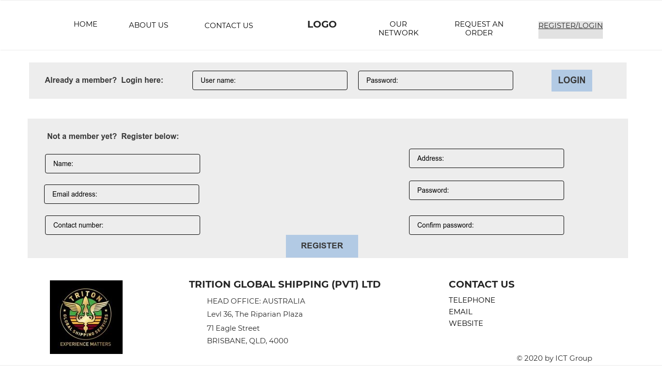

## Testing

Software evaluation involves conducting a function or device function of the programme to determine one or more interesting properties. Those properties usually indicate the degree to which the part or device is being evaluated.

By implementing a testing system, the system's functionality and capabilities can be validated.

**Black box testing**

Advantages

* Analysis is conducted from the user's point of view and helps to detect inconsistencies in requirements.
* Tester does not learn the programming languages or how to execute the applications.
* Reviews should be carried out by an impartial group of developers, allowing an unbiased view and the avoidance of developer-biases.
* When the requirements are complete, test cases can be built.

Disadvantages

1. Only a few possible inputs can be tested, and many programme paths are left untested.
2. Test cases would be difficult to build without clear requirements which are the situation in many projects.
3. Tests can be unnecessary if a test case is already run by the software designer / developer.

**PHPUnit**

PHPUnit is a framework independent library for unit testing PHP. Unit testing is a method by which small units of code are tested against expected results.

With unit testing we test each component of the code individually. All components can be tested at least once. A major advantage of this approach is that it becomes easier to detect bugs early on. The small scope means it is easier to track down the cause of bugs when they occur.

NetBeans provides tools for using PHPUnit, generates report of code coverage and more features when testing the web application.

# References

1. Royce, W. (1998). Software project management. Pearson Education India.
2. Futrell, R. T., Shafer, L. I., & Shafer, D. F. (2001). Quality software project management. Prentice Hall PTR.
3. Myers, G. J., Badgett, T., Thomas, T. M., & Sandler, C. (2004). The art of software testing (Vol. 2). Chichester: John Wiley & Sons.
4. Beizer, B. (2003). Software testing techniques. Dreamtech Press.
5. Ammann, P., & Offutt, J. (2016). Introduction to software testing. Cambridge University Press.
6. Ruparelia, N. B. (2010). Software development lifecycle models. ACM SIGSOFT Software Engineering Notes, 35(3), 8-13.
7. Leau, Y. B., Loo, W. K., Tham, W. Y., & Tan, S. F. (2012). Software development life cycle AGILE vs traditional approaches. In International Conference on Information and Network Technology (Vol. 37, No. 1, pp. 162-167).
8. Siau, K. (2004). Enterprise resource planning (ERP) implementation methodologies. Journal of Database Management, 15(1), I.